**Project Proposal**

**Project Description:**

This project is called Castle Defense.

This is a strategy game which requires players to come up with a good plan to protect their castle. Enemies will approach player’s castle through a path and players can deploy different kinds of weapons to kill the enemies and protect their castle. They lose the game if too many enemies attack their castle.

**Competitive Analysis:**

Apart from the general description of the game, here are some more specific main features of this game. The following competitive analysis will be based on these features.

* Weapons
  + Normal weapon with bullets
  + Weapon with ice bullets that can make enemies slow down
  + Weapons without bullets but attack ALL the enemies within its range
  + Weapons which has bullets that are 'reusable'
  + All weapons can be upgraded by paying more or remove
* Enemies
  + Different characteristics
  + Show progress bar
* Map
  + Default Maps with different difficulties
  + Self-create map and check validity
* Obstacles
  + Certain number of obstacles will exist in map to avoid users to put weapons in those positions
  + Weapons can attack obstacles to clear them
  + Different kinds of bonus will appear
* Money
  + Gained by attacking enemies, obstacles
* Other features
  + Background music and sound effect

Here are the three competitors I chose. All of them are tower defense games.

CarrotFantasy has really cute game figures and it is really easy to get started with playing it. The start point and the end point are clearly indicated.

KingdomRush has many fancy featured one-time weapons so that users can have fun with it.

Realm defense has multiple start point for enemies to appear, which increases the level of difficult of the game.

|  |  |  |  |  |  |
| --- | --- | --- | --- | --- | --- |
|  | **Flexibility of position to place weapons** | **Easy to find the correct level of difficulty** | **Things to do when playing game** | **Difference in weapons** | **Easy to understand the rule** |
| CarrotFantasy | Many spots to place weapons | Cannot skip easy levels for experienced players. Can play with double speed. | Money increases fast, so users can deploy more weapons | Only weapons built off the path. | Easy to understand |
| KingdomRush | Weapons can only be placed in very limited spots | Cannot skip easy levels for experienced players. Cannot play with double speed. | Money increases slow, so players can just sit there and watch in the beginning. | Soldiers on the path fight against enemies and blazing skies that is extremely destructive. | Easy to understand |
| Realm defense | Weapons can only be placed in very limited spots | Cannot skip easy levels for experienced players. Can play with double speed. | Money increases slow, so players can just sit there and watch in the beginning. | Various weapons, including putting soldiers on the path and fight against enemies. | Hard to understand |

Based on the comparison I did for the 3 existing tower defense games, I can obtain the following conclusion.

* In order to make my game competitive, I should allow users to build their weapons at more positions so that they are more flexible with their strategy. They have to really think carefully about their strategy given such flexibility.
* For better user experience for experienced players who think easy level of difficulty is boring, they can skip the easy levels and directly go to the harder ones.
* In two of the games, money increasement is really slow, and players can feel boring when just watching and waiting for the money to increase. In my game, money should be increased faster so that players always have things to do.
* My weapons should also be as differentiated as that of Realm defense and KingdomRush so it brings more fun to players.
* I should make my rules easy to understand. Instructions should be provided clearly in instruction screen.
* None of the games can let players self-create the map. This makes my game special among them and I should take advantage of that.

**Structural Plan:**

Main file:

Class of game modes

Class of splash screen

Class of instruction screen

Class of CreateMap mode

Class Enemy

function move

etc.

Class Weapon

Function that in charge of upgrade, remove, build weapons

Function attack

Etc.

Class obstacle

Class of different types of enemies inherit from class Enemy.

Class of different types of weapons inherit from class weapons.

Class of different types of bullets.

**Algorithmic Plan:**

1. Find which enemies to attack first and the direction of where the bullets go

* A list of enemies. See the very first enemy that enter the attack range of a weapon
* The range of the weapon will be a circular range will different radius
* The direction of the bullets has something to do with the position of the enemy that should be attacked

1. Generate a set of enemies with different levels of strength

* Change the speed of the enemies so that they will approach the castle faster
* Change of the lives of the enemies

1. Determine where the weapons can be placed on certain positions

* For some weapons, can only be placed in the cell if cell not in the route.
* For others, the reverse

1. Self-created maps

* Need to check whether the map is legal
* Check if it is a possible route from beginning to castle
* Check if it has enough obstacles on it

**Timeline Plan:**

* 11.21 – finish the algorithm for bullet

11.22 – implement different types of weapons

11.23 – 24 – finish coding for main features. Enemies should be able to be killed and weapons should be able to attack obstacles

11.25 – wrap up with things to reach MVP

11.26 – 12.1: finish the self-created map feature

12.2 – 12.3 – fixed small things and finish the project

12.4 – prepare the final TP package, including the video.

**Version Control Plan:**

* I plan to back up my code in OneDrive, which is shown below.

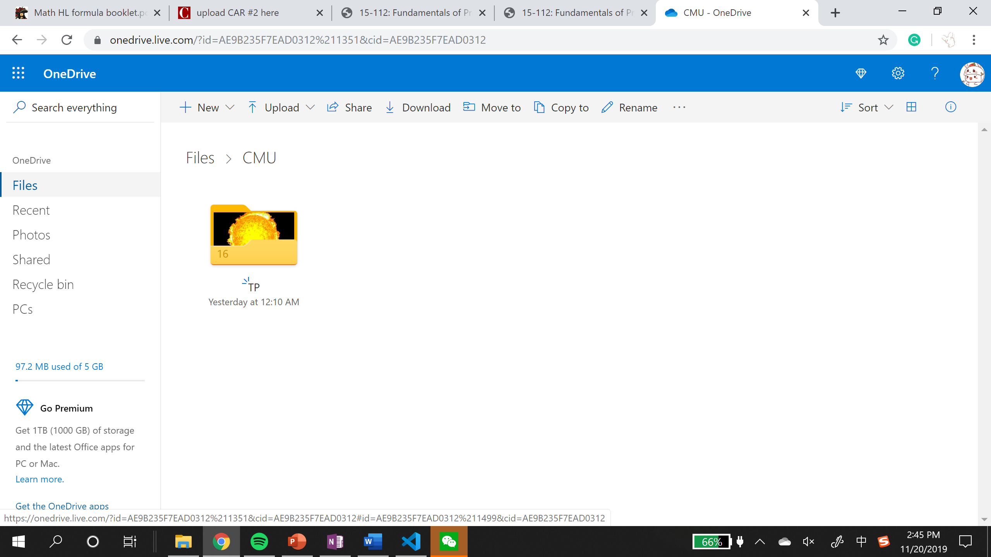

**Module List:**

* I’m using pygame for my term project.

**TP2 update**

Tower defense:

* Weapons
  + Normal weapon with bullets
  + ~~Weapon with ice bullets that can make enemies slow down~~
  + Weapons without bullets but attack ALL the enemies within its range
  + ~~Weapons which has bullets that are 'reusable'~~
  + All weapons can be upgraded by paying more or remove

I’m not doing the reusable bullets since it is not significantly algorithmically difficult from the normal tower weapon. All I have to do is to change the True to False in check collision.

Also, I’m not doing the bullets making enemies slow down since it’s also similar to the normal ones.

I would like to add a weapon that is significantly different. Inspired by the competitive analysis, I decided to add a weapon called Chili that can be put anywhere on my screen, including the path. Chili is a one-time use weapon that can attack all enemies in a horizontal line but cannot attack obstacles.

* Enemies
  + Different characteristics (speed and life)
  + Show progress bar
* Map
  + Default Maps with different difficulties
  + Self-create map and check validity
* Obstacles
  + Certain number of obstacles will exist in map to avoid users to put weapons in those positions
  + Weapons can attack obstacles to clear them (click on the weapons to attack them)
  + ~~Different kinds of bonus will appear~~

Again, this is more about quantity if I only change the image, life and bonus. So I decide not to do it with different bonus. All obstacles are stone and gives the same bonus.

* Money
  + Gained by attacking enemies, obstacles
* Buttons and menus
  + Buttons are turned gray if player does not have enough money for their weapons.
  + When affordable, buttons are colorful
  + Include a range indicator button that can show and not show the attack range of each weapon.
* Other features
  + Background music and sound effect

Tp 3 Update

* New enemy – pumpkin man that reduce the attack range and damage of a weapon when approaching it. Only exists in hard mode
* Allow users to create their own map (route, obstacle positions, number of enemy waves, amount of money to start with), can be saved for use next time
* Allow users to create their own robot enemy, which can be used in their self-created maps
* Background music added
* Weapon upgrades increases both range and damage